**Comprehensive Water Chemistry Analysis of District Gujrat**

**BY**

**Muhammad Usman**

**Raja Yawar Waheed**

**Department of Earth Sciences**

**Quaid-I-Azam University Islamabad, Pakistan**

Table of Contents

1 Introduction 3

2 Study Area 4

2.1 Geology of Gujrat 5

2.2 Hydrogeology and aquifer systems 6

3 Data and Methodology: 7

4 RESULTS: 9

4.1 Hydrochemistry Of the Area 9

4.2 Gibbs Plot: 11

4.3 Hydro Geochemical Facies: 13

4.4 Agriculture Potential Analysis: 15

4.4.1 Sodium Percentage 17

4.4.2 Kelley’s Ratio 19

4.4.3 Magnesium Adsorption Ratio (MAR) 20

4.4.4 Total Hardness (TH) 20

4.5 Health risk analysis 21

4.5.1 Fluoride Concentration 21

4.5.2 Health Risk Assessment 22

5 Conclusion 25

# Introduction

Access to clean and safe drinking water is paramount for maintaining optimal physical and mental well-being. In the context of Pakistan, where a significant portion of the population relies on groundwater aquifers and surface water sources such as rivers, lakes, and reservoirs, ensuring the safety and quality of drinking water is of utmost importance. The district of Gujrat in Punjab, Pakistan, faces unique challenges that hinder the maintenance of a clean and reliable water supply. Notably, the presence of sodium contamination in the district's water sources warrants a comprehensive health risk assessment and hydrochemical appraisal.

The primary objective of this study is to explore the intricate relationship between sodium pollution and associated health risks, as well as to gain insights into the chemical composition of the water sources in District Gujrat. By investigating the levels of sodium in drinking water and its implications, this study aims to contribute evidence-based strategies for safeguarding public health and fostering sustainable water management practices.

Sodium is an essential mineral required by the human body in limited quantities. However, elevated levels of sodium in the water supply can have detrimental effects on individuals' well-being, particularly for those with pre-existing conditions such as hypertension or cardiovascular diseases. Hence, conducting a comprehensive health risk assessment is vital to ascertain the potential impact of sodium contamination on the local population's health.

Furthermore, a thorough hydrochemical assessment is imperative to determine the composition and characteristics of the water sources in District Gujrat. This evaluation encompasses various factors, including pH levels, electrical conductivity, total dissolved solids, and specific ions such as sodium. By scrutinizing the hydrochemical properties of the water, valuable insights can be gained regarding the sources and mechanisms of sodium contamination, differentiating between natural geological processes and anthropogenic activities.

The findings derived from this health risk assessment and hydrochemical appraisal will provide crucial guidance for policymakers, water management authorities, and public health officials in formulating effective strategies to address sodium contamination and mitigate associated health risks. Ultimately, the objective is to ensure that the residents of District Gujrat have access to safe and clean drinking water. Moreover, the outcomes of this study aim to promote sustainable water management practices, enhance public health protection measures, and enhance the overall quality of life in the region.

# Study Area

This study centers around District Gujrat, located in Punjab, Pakistan. District Gujrat comprises three tehsils, each with distinct characteristics. These are Kharianwala, Sara-e-Alamgir, and Gujrat.

Gujrat, along with Fatehpur Sikri and Dipalpur, stands as one of the three historical towns in the subcontinent that were intentionally planned before their construction. Unlike Dipalpur, which was established to accommodate the royal army, or Fatehpur Sikri, conceived as the imperial capital, Gujrat was initially designed as a town for the common people. Situated atop a small mound, clearly visible from the Grand Trunk Road, it lies approximately five miles north of the meandering loops of Chenab River. The mound is believed to hold the remnants of at least two previous towns, with the more recent one thought to have been destroyed by the Mongols during the reign of Alauddin Khilji. At the command of the Mughal emperor Akbar, the current town was built, fortified with a thick wall, and garrisoned with Gujars. It was named Gujar Akbarabad. In the seventeenth century, Gujrat thrived as a prominent trade center and boasted a vibrant craft tradition. In 1849, Gujrat was designated as the district headquarters.

Gujrat holds a distinctive status within Punjab due to its manufacturing capabilities and production capacities. The district is home to approximately 1,059 industrial units operating at various scales, including cottage-level, small, medium, and large enterprises. Notably, Jalalpur Jattan, a major town in Gujrat, houses numerous textile industrial units of varying sizes. Additionally, the district accommodates a range of other industrial facilities involved in the production of electrical goods (such as fans), electric motors, earthen utensils, shoes, rubber tire tubes, sanitary ware, rice cleaning mills, and furniture. The high-quality furniture produced in Gujrat has been utilized in the National and Provincial Assemblies.

Gujrat is an ancient city of Pakistan located between two famous rivers, Jhelum River and Chenab River. It is bounded to the northeast by Azad Kashmir; to the northwest by the Jhelum River; to the east and southeast by the Chenab River, separating it from the districts of Gujranwala and Sialkot; and to the west by Mandi Bahauddin District. Gujrat consists of three tehsils: Sarai Alamgir, Kharianwala and Gujrat.

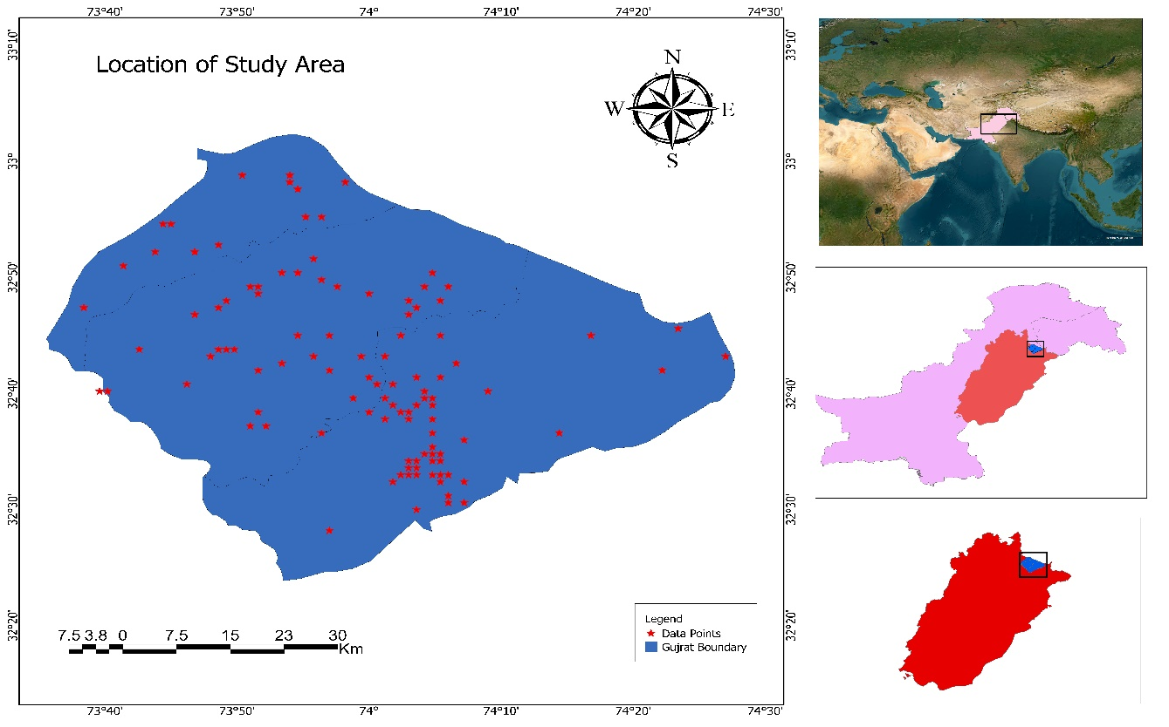

Figure ‎2.1: Location of Study Area

## Geology of Gujrat

The study area in question encompasses a vast and dynamic sedimentary basin known as the Potwar basin, located within the Punjab province of Pakistan. This region is characterized by a diverse range of geological formations, including Himalayan molasse sediments, inundated stream and flood plain deposits, terrigenous sedimentary rocks, and older terrace sediments. The geological composition of the area consists of various materials such as clay, sandy clay, dry sandy soil, gravels, and boulders.

The molasse deposits found here can be broadly classified into two main groups: the Rawalpindi group and the Siwalik group. The Rawalpindi group, which dates back to the Miocene age, further comprises two formations: the Murree Formation and the Kamlial Formation. The Murree Formation is characterized by cyclic deposition of clay and sandstone, while the Kamlial Formation is predominantly composed of sandstone.

On the other hand, the Siwalik group, which originated during the Pleistocene age, consists of four formations: the Chinji Formation, the Nagri Formation, the Dhok Pathan Formation, and the Soan Formation. The Chinji Formation primarily consists of 70% clays and 30% friable sandstone, whereas the Nagri Formation exhibits a composition of 30% clay and 70% sandstone. Similarly, the Dhok Pathan Formation presents an equal distribution of 50% clay and 50% sandstone. Lastly, the Soan Formation represents the most recent deposits, characterized by conglomerates (Shah, 2009). It is worth noting that the recent alluvium deposits form the uppermost layer of the geological composition in the area. These deposits are composed of patches of clay, sand, silt, gravels, and boulders.

The geological landscape of Gujrat is a captivating amalgamation of diverse sedimentary formations and deposits. The intricate interplay between the Rawalpindi group and the Siwalik group, along with the presence of alluvium deposits, paints a vivid picture of the geological history that has shaped this region over time.

## Hydrogeology and aquifer systems

Gujrat encompasses a diverse range of terrigenous sedimentary rocks, including stream deposits, flood plain deposits, detrital sedimentary rocks, and the prominent Siwalik group of rocks. These sediments coexist in varying proportions, creating a complex interplay between sandy clay and clayey sand. It is worth noting that the sand, gravel, and their mixtures within these formations serve as significant water-bearing strata, thus exhibiting relatively enduring water production potential.

Within the research area, the Siwalik Group of rock formations also makes its presence felt. The sandstone within these formations possesses a soft texture, rendering it suitable for water storage purposes. Conversely, the clays act as barriers, impeding groundwater storage in the subsurface. The aquifers in this region predominantly exhibit confined characteristics, with certain localized areas manifesting unconfined aquifers featuring a top layer composed of gravels and boulders.

Furthermore, the aquifers within this region experience recharging primarily through effective infiltrations and seasonal tributaries that drain the area. Notably, the region receives an annual rainfall of approximately 1033 mm, as recorded by climate-data.org. Additionally, the majestic Jhelum River gracefully traverses the north western part of the area, while several canals branching out from the river enhance the hydrological network within the region. These water bodies, alongside the seasonal drainage patterns, serve as the primary sources of recharging the subsurface aquifers, sustaining their water levels.

The climatic conditions in the area contribute to unique dynamics, as the lingering heat from the sun during summer evenings influences the hydrological processes. Consequently, the water table within the research area experiences fluctuations, intricately tied to the seasonal patterns of recharging.

Gujrat presents a captivating geological composition, characterized by a blend of diverse terrigenous sedimentary rocks and the influential Siwalik group formations. The intricate interplay between sandy clay and clayey sand offers valuable insights into the subsurface hydrological dynamics. The aquifers, both confined and unconfined, contribute significantly to water production, with recharging primarily driven by effective infiltrations and the presence of various water bodies, including the Jhelum River and its associated canals. Understanding the delicate balance between geological formations, hydrological processes, and climatic influences is crucial in comprehending the water resource potential and sustainability within this remarkable region.

# Data and Methodology:

The present study conducted in the district of Gujrat involved a meticulous collection of 407 water samples for thorough analysis. Among the three tehsils surveyed, Tehsil Gujrat accounted for the highest number of samples (217), followed by tehsil Kharianwala (147) and tehsil Sara-e-Alamgir (43). These samples were strategically collected in proximity to water lines or river lines, ensuring a representative dataset for analysis. Polythene bottles, thoroughly cleaned with distilled water and nitric acid solution, were utilized as the collection containers. Prior to sampling, wells were pumped for 10-15 minutes to obtain water that best reflected the current hydrological conditions.

To gain immediate insights into the physiochemical characteristics of the collected samples, in-situ measurements were conducted using portable meters to determine Total Dissolved Solids (TDS), Electrical Conductivity (EC), and pH values. These measurements were essential in gauging the overall quality and composition of the water samples.

Following the collection phase, the samples were diligently labeled with the respective date and location information and expeditiously transferred to the laboratory for further analysis. The lab analysis primarily focused on determining the concentrations of cations, such as Sodium (Na+), Potassium (K+), Magnesium (Mg), and Calcium (Ca), which were quantified using a flame photometer. Additionally, the presence of arsenic was detected using an atomic absorption spectrometer. For the quantification of certain anions, including Fluoride (F-), Chloride (Cl-), Bicarbonate (HCO3-), and Carbonate (CO3), the titration method was employed.

The collected data was subjected to comprehensive statistical analysis, which encompassed calculating the minimum, maximum, and average values of the physiochemical parameters. Furthermore, the obtained ion concentrations were compared against the limits prescribed by the World Health Organization (WHO), ensuring a robust evaluation of the water quality.

To visually interpret the distribution of ions within the water samples, two graphical methods were employed: the Piper plot and the Gibbs plot. The Piper plot, composed of two triangles representing major cations (Ca, Mg, Na+K) and major anions (SO4, Cl, HCO3- + CO3), respectively, allowed for a comprehensive visualization of the ion compositions. The diamond shape in the plot represented the combined presence of both anions and cations. Conversely, the Gibbs plot considered various climatic conditions that influenced the water chemistry in the study area. It classified the water chemistry into five distinct classes: evaporation dominance, evaporation crystallization dominance, rock dominance, atmospheric precipitation dominance, and rainfall dominance. These graphical representations proved invaluable in discerning patterns and trends within the water chemistry dataset.

By employing these rigorous analytical and graphical methodologies, the study shed light on the intricate water chemistry within the Gujrat district. The obtained results were effectively compared against the stringent standards set by the WHO, facilitating a comprehensive assessment of water quality. Such insights are crucial for formulating appropriate measures and interventions to ensure the provision of safe and potable water to the residents of Gujrat.

# RESULTS:

## Hydrochemistry Of the Area

The data contains 407 total samples. Table 1 shows the values for physiochemical parameters along with the range of samples that lie within the limit standardized by the WHO (World Health Organization). The values for EC and TDS are also given in the table. For EC the samples within range of WHO standards are 95.82% and out of limit are 4.18%. Similarly, the percentage of sample within limits is 92.87% and out of limit are 7.13% for TDS. TDS is slightly higher due to the involvement of the cations Na, K, Cl and SO4. The samples out of range for cations Na are 6.14% and for K is 3.69%.Similarly the samples that do not fall in limit of WHO parameters for anions Cl are 2.70% and SO4 are 6.14%. Both are heavier and act as contaminants in water. The third contaminant is HCO3 having 16.46% as exceeding limit. Fluoride also has 2.95% sample exceeding the WHO limit.

PH ranges from 3-9 having 92% samples within the limit of WHO standards and 7.86% samples out of limit. Hardness values range from 30-1450 mg/l having 94.84%samples within limit. There are no traces of carbonate being present in the area whereas value for bicarbonate ranges from 35-2010 having 83% values within the limit of WHO standards. Ca and Mg have values ranging from 10-450 and 0-134 respectively. Both have 99% samples within the limit. NO3, PO4, and Fe have more than 99% samples within the limit. The statistical summary of the examined parameters and their comparison with WHO is given in the table below:

Table ‎4.1: Comparison with WHO Standard Limits

|  |  |  |  |  |  |  |  |
| --- | --- | --- | --- | --- | --- | --- | --- |
| Parameters | Unit | WHO Limits | Samples within Range | Samples out of Range | Total Samples | Percentage Within Limit | Percentage Out of Limit |
| EC | µS\cm | 1500.00 | 390 | 17 | 407 | 95.82 | 4.18 |
| TDS | mg/l | 1000.00 | 378 | 29 | 407 | 92.87 | 7.13 |
| pH | -- | 6.5-8.5 | 375 | 32 | 407 | 92.14 | 7.86 |
| HCO3 | mg/l | 350.00 | 340 | 67 | 407 | 83.54 | 16.46 |
| CO3 | mg/l | 200.00 | 407 | 0 | 407 | 100.00 | 0.00 |
| Cl | mg/l | 250.00 | 396 | 11 | 407 | 97.30 | 2.70 |
| SO4 | mg/l | 400.00 | 382 | 25 | 407 | 93.86 | 6.14 |
| Ca | mg/l | 300.00 | 405 | 2 | 407 | 99.51 | 0.49 |
| Mg | mg/l | 150.00 | 407 | 0 | 407 | 100.00 | 0.00 |
| Hardness | mg/l | 500.00 | 386 | 21 | 407 | 94.84 | 5.16 |
| Na | mg/l | 200.00 | 382 | 25 | 407 | 93.86 | 6.14 |
| K | mg/l | 10.00 | 392 | 15 | 407 | 96.31 | 3.69 |
| NO3 | mg/l | 45.00 | 407 | 0 | 407 | 100.00 | 0.00 |
| PO4 | mg/l | 0.30 | 405 | 2 | 407 | 99.51 | 0.49 |
| F | mg/l | 1.50 | 395 | 12 | 407 | 97.05 | 2.95 |
| Fe | mg/l | 3.00 | 407 | 0 | 407 | 100.00 | 0.00 |
| As | µg/l | 10.00 | 407 | 0 | 407 | 100.00 | 0.00 |

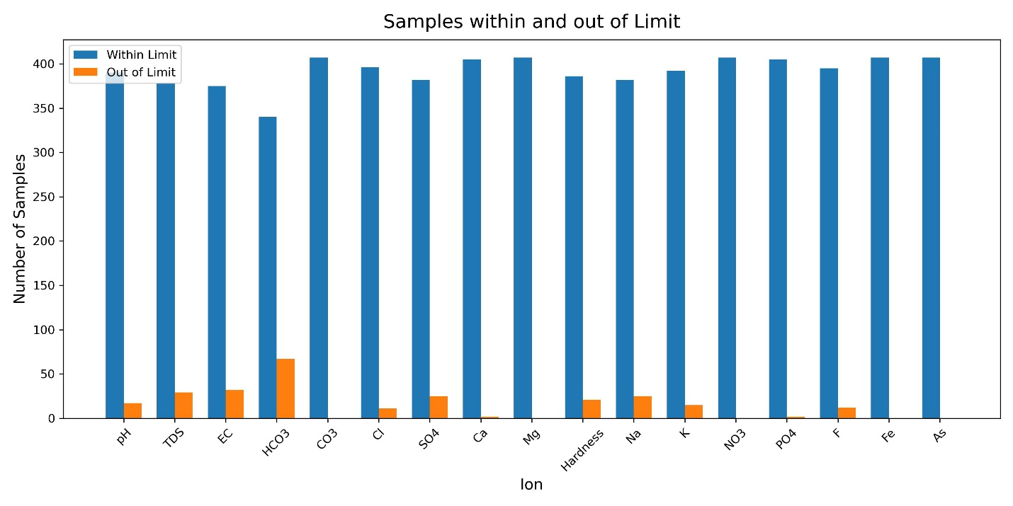

Figure ‎4.1: Distribtio of different Parameters against WHO Limits

The table below provides a summary of the classification and distribution of water samples based on their salt enrichment levels (classified as Type 1, Type 2, and Type 3) and their respective electrical conductivity (EC) ranges. The data is presented for different towns within the specified region. Following table shows the percentage distribution of water samples in each town for each salt enrichment type. Type 1 represents water samples with low salt enrichment(<1500), Type 2 represents medium salt enrichment(1500-3000, and Type 3 represents high salt enrichment(>3000).

Table ‎4.2: Classification based on Electrical Conductivity (EC) values

|  |  |  |  |  |  |  |  |  |  |
| --- | --- | --- | --- | --- | --- | --- | --- | --- | --- |
| Class | Gujrat | Kharianwala | Sara-e-Alamgir | Total | Gujrat (%) |  | Kharianwala (%) | Sara-e-Alamgir (%) | Total (%) |
| Type 1 | 202 | 130 | 43 | 375 | 53.866667 |  | 34.666667 | 11.46 | 92% |
| Type 2 | 9 | 12 | 0 | 21 | 42.857143 |  | 57.142857 | 0 | 5% |
| Type 3 | 6 | 5 | 0 | 11 | 54.545455 |  | 45.454545 | 0 | 3% |

## Gibbs Plot:

The Gibbs plot stands as a powerful graphical method employed in the meticulous analysis of water chemistry within a specific geographical region, taking into account the diverse influence of various climate conditions. By delving into the intricacies of the Gibbs plot, valuable insights can be gained regarding the dominant processes and factors that shape the water chemistry within the study area. This graphical representation serves as a valuable tool in unraveling the complex interplay of elements that contribute to groundwater chemistry.

The Gibbs plot effectively illustrates a range of processes that can significantly impact the chemistry of groundwater. These processes include evaporation dominance, evaporation crystallization dominance, rock dominance, atmospheric precipitation dominance, and rainfall dominance. By closely examining the spatial arrangement of data points on the Gibbs diagram, the key controlling processes governing water chemistry can be discerned, providing crucial information for comprehensive analysis.

Construction of the Gibbs plot involves the utilization of two vital ratios: one for anions and one for cations. The anion ratio, calculated by dividing the chloride ion concentration (Cl-) by the sum of chloride and bicarbonate ion concentrations (Cl- + HCO3-), enables an in-depth understanding of anionic contributions to water chemistry. Similarly, the cation ratio, calculated by dividing the sum of sodium and potassium ion concentrations (Na) by the sum of sodium and calcium ion concentrations (Na + Ca), sheds light on the relative abundance of cations.

Displayed within the Gibbs plot are the distributions of cations and anions. It is noteworthy that the majority of the analyzed samples exhibit TDS (Total Dissolved Solids) values falling within the range of 100-10000. TDS values within the range of 1000 -10000 indicate the influence of evaporation processes. Furthermore, TDS values ranging from 1000-10000 signify the effect of "Rock Dominance" on water chemistry.

Based on our comprehensive analysis and interpretation of the obtained results, it can be confidently stated that the water chemistry of District Gujrat is predominantly controlled by the intricate interplay of rock dominance and evaporation crystallization processes. These findings provide valuable insights into the underlying mechanisms shaping the water composition within the region, facilitating a more profound understanding of the hydrological dynamics and contributing to informed decision-making regarding water resource management.

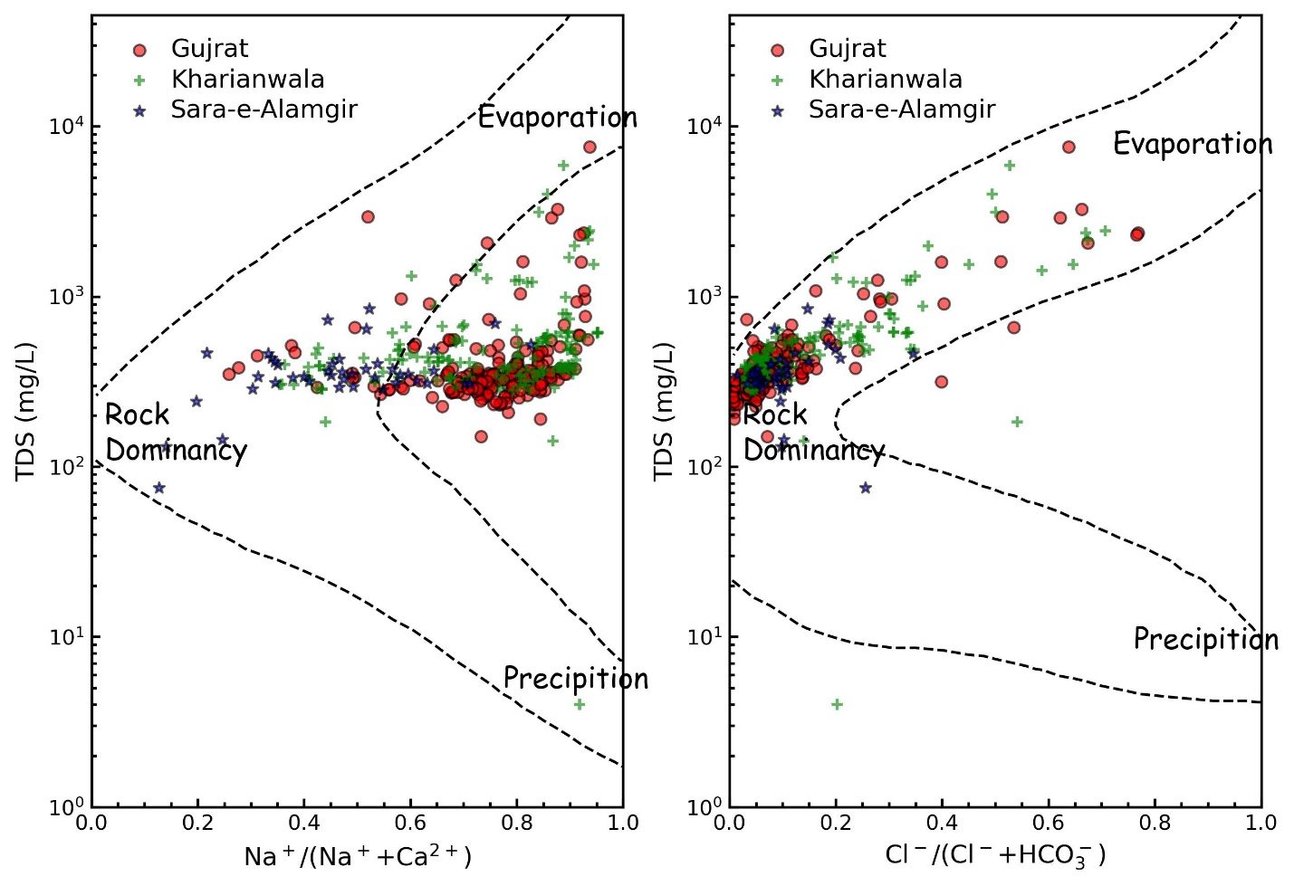

Figure ‎4.2: Gibbs Plot

## Hydro Geochemical Facies:

The Piper plot, a trilinear diagram, is a graphical tool for analyzing and classifying water chemistry. It utilizes three equilateral triangles to represent the concentrations of major cations (calcium, magnesium, sodium, and potassium) and major anions (bicarbonate, sulfate, and chloride). These triangles connect to form a hexagon, revealing the intricate composition of water samples in a visually concise manner.

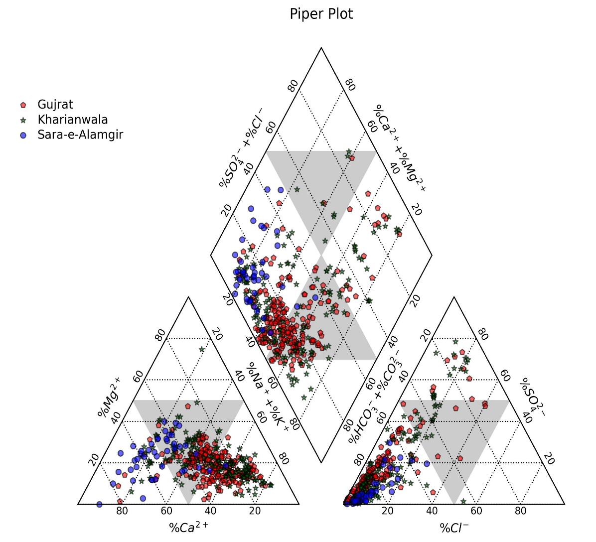

Figure ‎4.3: Piper Plot

Table ‎4.3: Ion Concentrationbased on Piper Plot

|  |  |
| --- | --- |
| Denotation | Classes |
| 1 | Mixed Ca Mg Cl SO4 type |
| 2 | SO4 Cl-Na type |
| 3 | HCO3-Na Mg type |
| 4 | HCO3-Ca Mg type |
| A | Calcium Type |
| B | No dominant Zone |
| C | Magneisum Type |
| D | Sodium Type |
| E | Bicarbonate Type |
| F | Sulfate type |
| G | Chloride Type |

The figure represents the water sample points collected from district Gujrat. From the figure we can observe that most of the samples lie in Sodium dominance Zone D. Data points can also be seen in Zone E. Zone E is related to the dominance of Bicarbonate. In the diamond the data is acumulated in 2 zones that are 2 and 4. Zone 2 represents the SO4 Cl-Na type whereas Zone 4 represents HCO3-Ca Mg type. The figure represents the samples in different colors showing different tehsils.

## Agriculture Potential Analysis:

SAR (Sodium Adsorption Ratio) is a measurement used to assess the suitability of water for irrigation by evaluating its sodium content. It compares the concentration of sodium ions to the concentrations of other cations like calcium and magnesium. SAR is calculated in milliequivalent per meters using formula:

Sodium Adsorption Ratio (SAR) values are categorized into four distinct ranges: excellent, good, doubtful, and unsuitable. The range of excellent SAR values extends from 0 to 10, denoting highly favourable conditions for irrigation. Good values encompass the range of 10 to 18, while doubtful values fall between 18 and 26. Unsuitable values exceed 26, indicating a heightened risk of soil degradation due to sodium content. It is crucial to note that crop and soil tolerances may exhibit regional variations, necessitating the consideration of specific geographical conditions and agricultural practices.

The provided table presents comprehensive information regarding the levels of Sodium Adsorption Ratio (SAR) in various areas, including Gujrat, Kharianwala, and Sara-e-Alamgir. Upon analyzing the data, it becomes apparent that a significant number of samples in most areas fall within the excellent to good range, signifying favourable SAR levels suitable for irrigation purposes. Nonetheless, there are also instances where samples fall within the doubtful and unsuitable ranges, indicating potential limitations for irrigation in those samples or areas.

The table further reveals pertinent information regarding the Sodium Adsorption Ratio (SAR) levels in different regions, encompassing Gujrat, Kharianwala, and Sara-e-Alamgir. It is noteworthy that 26% of the total samples exhibit SAR values falling within the excellent range, while 40% samples fall in the good range of SAR values, thereby rendering the land highly suitable for agricultural practices.

Table ‎4.4: Classification based on SAR values

|  |  |  |  |  |  |  |  |  |
| --- | --- | --- | --- | --- | --- | --- | --- | --- |
| Class | Gujrat | Kharianwala | Sara-e-Alamgir | Total | Gujrat (%) | Kharianwala (%) | Sara-e-Alamgir (%) | Total (%) |
| Excellent | 29 | 40 | 38 | 107 | 13.551402 | 18.691589 | 17.757009 | 26% |
| Good | 126 | 35 | 3 | 164 | 38.414634 | 10.670732 | 0.914634 | 40% |
| Doubtful | 39 | 34 | 2 | 75 | 26 | 22.666667 | 1.333333 | 18% |
| Unsuitable | 23 | 38 | 0 | 61 | 18.852459 | 31.147541 | 0 | 15% |

The Wilcox diagram is a graphical tool utilized to assess the appropriateness of water for irrigation based on its sodium adsorption ratio (SAR) and electrical conductivity (EC) values. This diagram employs a triangular plot, where distinct zones delineate varying degrees of suitability for agricultural purposes. To corroborate the SAR findings, a graphical representation of the Wilcox diagram was employed in this study. The analysis reveals that approximately 85% to 90% of the total samples fall within the low to moderate SAR range. This outcome signifies that the land in these areas is highly conducive to agriculture, as the sodium content in the water remains within acceptable limits. Consequently, this discovery underscores the significant potential for successful agricultural practices in these regions, given the favorable quality of water available.

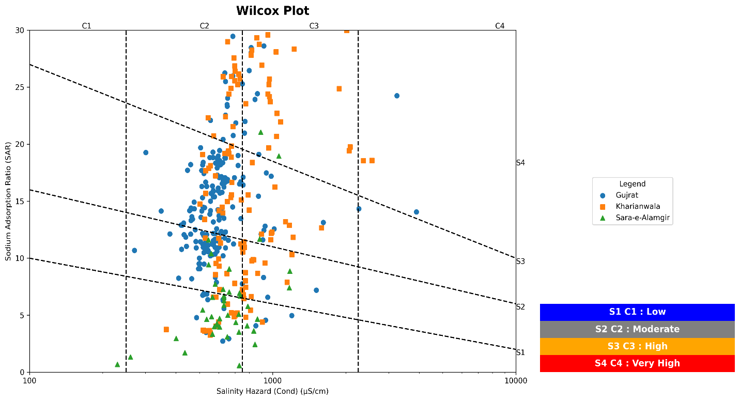

Figure ‎4.4: USSL Diagram showing salinity hazard

### Sodium Percentage

By utilizing the ratio of sodium and potassium to calcium and magnesium concentrations, the sodium percentage (Na%) was employed to ascertain the degree of salinity. Water containing elevated levels of sodium and potassium experiences a loss of calcium and magnesium ions, thereby impeding its mobility.

|  |  |
| --- | --- |
| **Range of Na%** | **Class** |
| < 20 | Excellent |
| 20 – 40 | Good |
| 40 – 60 | Permissible |
| 60 – 80 | Doubtful |
| > 80 | Unsuitable |

Table ‎4.5: Classification based on Sodium Percentage

|  |  |  |  |  |  |  |  |  |
| --- | --- | --- | --- | --- | --- | --- | --- | --- |
| Class | Gujrat | Kharianwala | Sara-e-Alamgir | Total Samples | Gujrat (%) | Kharianwala (%) | Sara-e-Alamgir (%) | Total Samples (%) |
| Excellent | 2 | 0 | 9 | 11 | 18.181818 | 0 | 81.818182 | 3% |
| Good | 15 | 34 | 27 | 76 | 19.736842 | 44.736842 | 35.526316 | 19% |
| Permissible | 91 | 39 | 6 | 136 | 66.911765 | 28.676471 | 4.411765 | 33% |
| Doubtful | 104 | 62 | 1 | 167 | 62.275449 | 37.125749 | 0.598802 | 41% |
| Unsuitable | 5 | 12 | 0 | 17 | 29.411765 | 70.588235 | 0 | 4% |

The table of Na% shows that it is evident that the samples from Gujrat and Kharianwala predominantly fall within the excellent range. This suggests that the sodium levels in these areas are within acceptable limits and pose no significant concerns. Moreover, a few samples from Sara-e-Alamgir also fall within the good and permissible range, indicating a relatively lower sodium content compared to other areas. However, 104 samples from Gujrat and 62 samples from Sara-e-Alamgir fall within the doubtful or unsuitable range, implying a higher sodium content that might be of concern. These findings emphasize the importance of careful evaluation and potential remediation measures in areas where sodium levels exceed recommended thresholds.

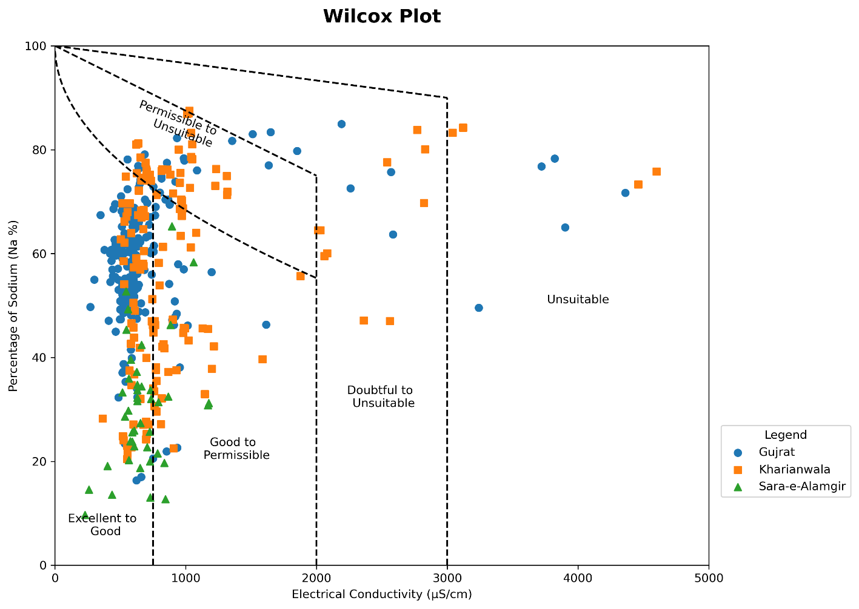

Figure ‎4.5: Wilcox Diagram

### Kelley’s Ratio

Utilizing the correlation between the concentration of sodium and calcium/magnesium in the borehole water, the Kelly's ratio (KR) was utilized to quantify the level of salinity. Excessive sodium combining with calcium and magnesium in irrigation water results in detrimental byproducts and inferior water quality, thereby adversely affecting the pace of plant growth and yield.

|  |  |
| --- | --- |
| **Range of KR** | **Class** |
| < 1 | Safe |
| > 1 | Unsafe |

Table ‎4.6: Classification based on Kelly's Ratio

|  |  |  |  |  |  |  |  |  |
| --- | --- | --- | --- | --- | --- | --- | --- | --- |
| Class | Gujrat | Kharianwala | Sara-e-Alamgir | Total | Gujrat (%) | Kharianwala (%) | Sara-e-Alamgir (%) | Total (%) |
| Safe | 53 | 60 | 40 | 153 | 34.640523 | 39.215686 | 26.143791 | 38% |
| Unsafe | 164 | 87 | 3 | 254 | 64.566929 | 34.251969 | 1.181102 | 62% |

### Magnesium Adsorption Ratio (MAR)

Based on the concentration of magnesium versus calcium the salinity level was calculated using the magnesium adsorption ratio (MAR). When irrigation water has a high ratio of magnesium to calcium, the water's pH rises.

|  |  |
| --- | --- |
| **Range of MAR** | **Class** |
| < 50 | Recommended |
| > 50 | Not Recommended |

Table .: Classification based on MAR values

|  |  |  |  |  |  |  |  |  |
| --- | --- | --- | --- | --- | --- | --- | --- | --- |
| Class | Gujrat | Kharianwala | Sara-e-Alamgir | Total | Gujrat (%) | Kharianwala (%) | Sara-e-Alamgir (%) | Total (%) |
| Not Recommended | 3 | 7 | 0 | 10 | 30 | 70 | 0 | 2% |
| Recommended | 214 | 140 | 43 | 397 | 53.904282 | 35.264484 | 10.831234 | 98% |

### Total Hardness (TH)

Based on the ratio of calcium to magnesium in the water, total hardness (TH) was utilized to calculate the salty substances level. Water quality is impacted by a high calcium vs magnesium concentration. It results in water hardness, which has an impact on how water is distributed from water delivery systems to crops.

|  |  |
| --- | --- |
| **Range of TH** | **Class** |
| 0 – 75 | Soft |
| 75 – 150 | Moderate |
| 150 – 300 | Hard |
| > 300 | Very Hard |

Table ‎4.8: Classification based on Total Hardness

|  |  |  |  |  |  |  |  |  |
| --- | --- | --- | --- | --- | --- | --- | --- | --- |
| Class | Gujrat | Kharianwala | Sara-e-Alamgir | Total | Gujrat (%) | Kharianwala (%) | Sara-e-Alamgir (%) | Total (%) |
| Soft | 0 | 1 | 1 | 2 | 0 | 50 | 50 | 0% |
| Moderate | 87 | 42 | 2 | 131 | 66.412214 | 32.061069 | 1.526718 | 32% |
| Hard | 109 | 67 | 32 | 208 | 52.403846 | 32.211538 | 15.384615 | 51% |
| Very Hard | 21 | 37 | 8 | 66 | 31.818182 | 56.060606 | 12.121212 | 16% |

## Health risk analysis

### Fluoride Concentration

Fluoride concentration in water is a topic of concern due to potential health risks. While fluoride is beneficial in preventing tooth decay when present at optimal levels, excessive fluoride can lead to health issues. High levels of fluoride in drinking water have been associated with dental fluorosis, a condition that causes discoloration and enamel damage to teeth. Prolonged exposure to elevated fluoride concentrations may also contribute to skeletal fluorosis, which affects the bones and joints, causing stiffness and pain. It is important to monitor and maintain fluoride concentrations within recommended limits to ensure public health and minimize the risks associated with excessive fluoride intake.

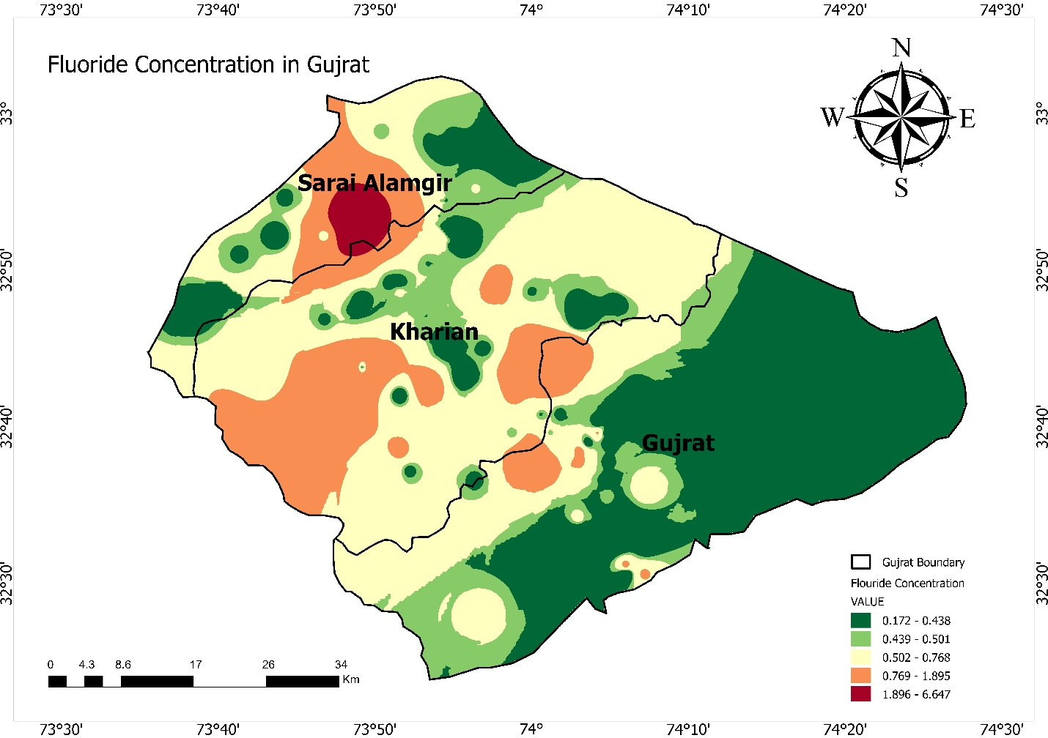

Figure ‎4.6: Map of Concentration of Fluoride in the study area

### Health Risk Assessment

The assessment of health risks plays a crucial role in evaluating the potential health implications associated with the presence of chemical constituents in water. These contaminants include heavy metals, organic compounds, disinfection byproducts, microbial pathogens, and emerging contaminants. Health risk evaluation often involves the use of a calculation called the Hazard Quotient (HQ) to quantify the risks.

The HQ is derived by first calculating the Average Daily Dose (ADD) of a specific contaminant using the formula:

In this context, C represents the concentration of fluoride in the water, IR represents the ingestion rate of water, ED denotes exposure duration, EF signifies the exposure frequency, BW represents body weight, and AT indicates the averaging time.

|  |  |  |  |
| --- | --- | --- | --- |
| **Age Group** | **IR (L/day)** | **BW (kg)** | **AT** |
| >20 years | 2 | 70 | 365 |

Following the determination of the ADD, the HQ is calculated by dividing the ADD by the Reference Dose (RFD) specific to fluoride. The RFD represents the acceptable daily intake level of fluoride below which adverse health effects are unlikely. For fluoride, the recommended RFD is typically set at 0.06 mg/kg body weight per day.

Quantitative assessment of potential health risks associated with fluoride exposure in water is vital for making informed decisions regarding water management, treatment, and mitigation strategies to protect public health and ensure the safety of drinking water sources.

It is important to note that the HQ calculation considers various factors, including fluoride concentration in water, uptake rate, exposure duration, frequency, body weight, and averaging time. While higher fluoride concentrations generally result in higher ADD, the resulting HQ is influenced by other factors and the fluoride-specific RFD value. A high fluoride concentration may not necessarily yield a high HQ if other factors are relatively low. Conversely, even at moderate or low fluoride concentrations, a high HQ can be obtained if other factors are relatively high or if RFD values are low. Thus, the overall HQ depends on the interaction between fluoride concentration and other variables in the calculation, such as RFD, exposure limits, and body weight.

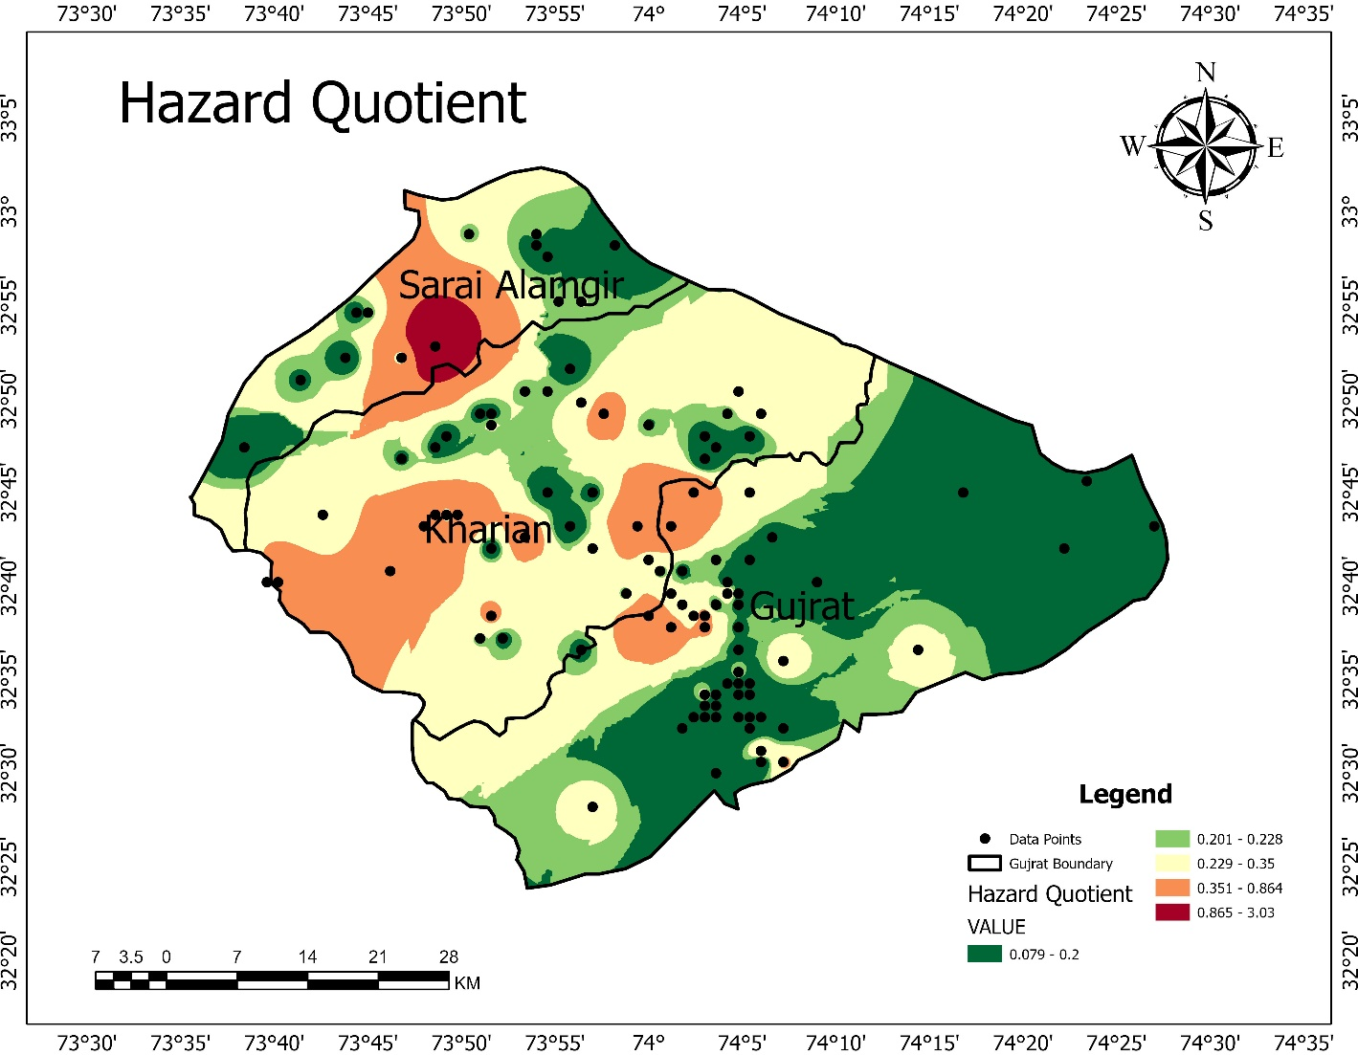

Figure ‎4.7: Hazard Quotient map for study area

# Conclusion

In conclusion, this study undertook a comprehensive assessment of health risks and hydrochemical characteristics associated with sodium contamination in the drinking water of District Gujrat, Punjab, Pakistan. The investigation encompassed multiple tehsils within the region, including Gujrat, Kharianwala, and Sara-e-Alamgir, with a total of 407 samples analyzed. Findings revealed that 95% of the samples met the standards set by the World Health Organization (WHO) for electrical conductivity (EC), while 5% exceeded the recommended limits. Likewise, within the parameters of Total Dissolved Solids (TDS), the presence of sodium, potassium, chloride, and sulfate ions caused 7% of the samples to surpass the established thresholds, while 93% remained within acceptable levels. Elevated levels of sodium and potassium were detected in 6% and 3% of the samples, respectively, surpassing WHO guidelines. Additionally, notable water contaminants such as fluoride, sulfate, and chloride were present in 2-6% of the samples, exceeding WHO standards. pH levels ranged from 3 to 9, with 92% of the samples falling within the recommended WHO range. Hardness values varied from 30 to 1450 mg/l, with 94.84% of the samples falling within acceptable limits. Bicarbonate concentrations complied with WHO standards in 83% of the samples. Calcium and magnesium levels were within the acceptable range for 99% of the samples. The majority of anions, including nitrate, phosphate, fluoride, and iron, were within the acceptable limits for more than 99% of the samples. The analysis of water chemistry using the Gibbs plot indicated that the hydrochemical characteristics of District Gujrat are primarily influenced by rock dominance and evaporation crystallization processes. The Piper diagram was employed to assess water chemistry. The agricultural risk analysis encompassed evaluating parameters such as Sodium Adsorption Ratio (SAR), sodium percentage, magnesium percentage, Kelley's ratio, and total hardness, while health risk assessment focused on analyzing fluoride contamination and hazard quotient. These findings emphasize the critical need to address the issue of sodium contamination and implement appropriate mitigation measures to safeguard public health and ensure the provision of safe drinking water in District Gujrat.